UI/UX case study – Gift-IT

Gift-IT is an online gift shopping website providing gift items for special life moments such as birthdays, weddings, anniversaries etc.

Information Architecture:

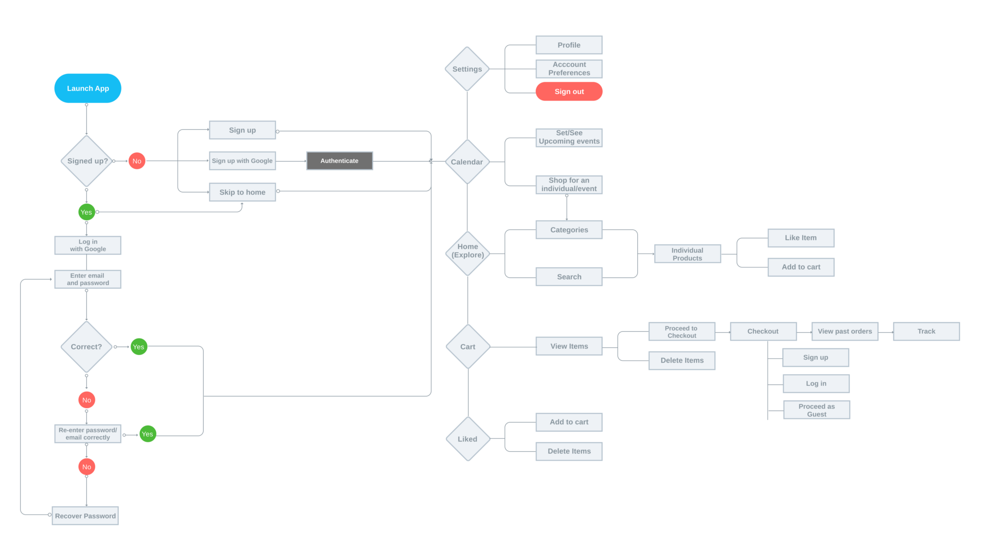

**Wireframes:**

<https://projects.invisionapp.com/share/ZKGVXBVQY6X#/screens>

**Reference Visuals:**

Note: Visual Mobile App UI, you must be design it as responsive Web UI

